The clinical trial was performed in order to understand the three different treatment options to understand the efficacy of reducing the progression to full diabetes. Initially, a calculation of the average for each option was calculated to briefly overview which treatment option had a better success rate. To dive deeper, a bootstrap was conducted to plot the KDE and the ECDF to determine how each group’s success rate varies by chance. A pairwise analysis was also done in order to check whether the comparison of two treatments could show a difference with plots and confidence interval calculations. After the analysis, the trial showed that rosiglitazone performs the best out of all treatment choices and should be the suggested option to carry through with additional testing.
Firstly, a cross tabulation of the data between the outcome and the treatment was calculated. The table looks as follows:

 | Failure | Success | All
lifestyle | 109 | 125 | 234
met | 120 | 112 | 232
rosi | 90 | 143 | 233
All | 319 | 380 | 699

This shows the number of failures and successes for each treatment style with the total counts for each group in the last column or row. The table best provides a basic overview of how many successes and failures each group had as a side-by-side comparison. Using this table, the averages of each treatment option can be calculated. Rosiglitazone has the highest success rate of 61.4%, Lifestyle has the second highest rate of 53.4% and finally Metformin has the lowest success rate of 48.3%. As Rosiglitazone has the highest success rate, it adds evidence that Rosiglitazone was the most effective out of all tested.
However, to add further evidence to the conclusion, bootstrapping was done to understand how that success rate could change due to chance. We visualize the bootstraps using the following plots initially:
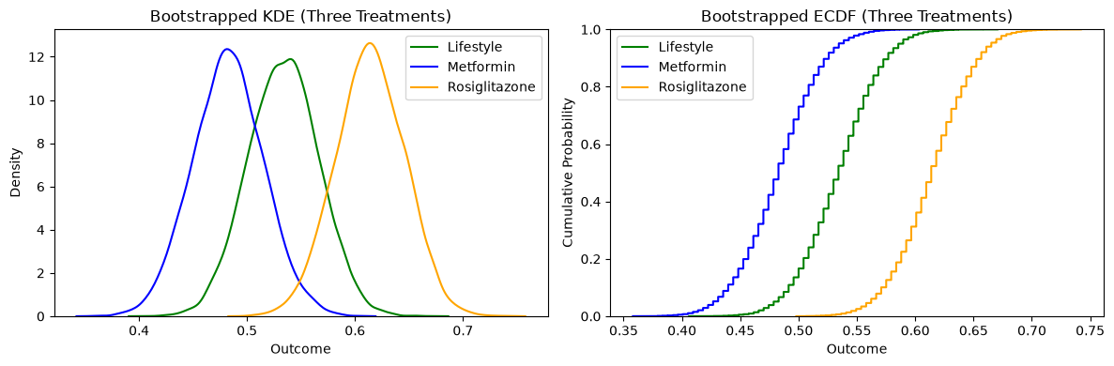

On the KDE and the ECDF plot, Rosiglitazone is the furthest to the right compared to the other treatments. Lifestyle changes is in the middle and closer to the last plot given by the Metformin curve. So, as Rosiglitazone is furthest to the right, it can be concluded from this plot as well that it shows the highest success rate if compared to the position of the plots for Metformin or Lifestyle Changes. In fact, Metformin could show the least effectiveness as its success rate data is concentrated further to the left of the graph. Also, it can be noticed that the Metformin and Rosiglitazone curves barely overlap on the KDE plot. This suggests that Rosiglitazone could be the better treatment option when compared to Metformin since most data obtained does not overlap with each other. Further, pairwise plots with bootstrapped ATE calculations were made to further understand the difference between each treatment group.

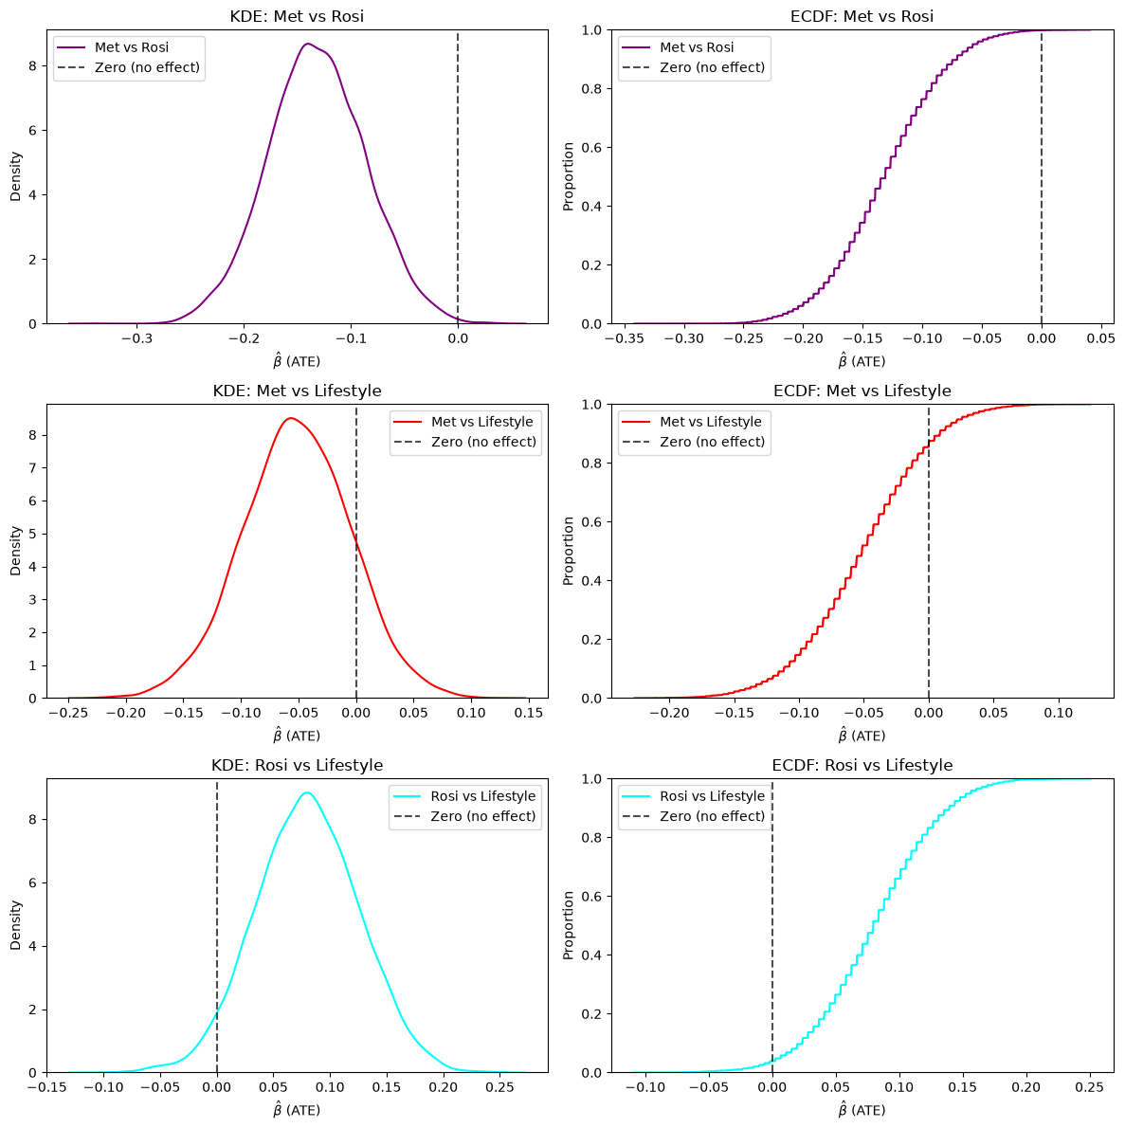

From these plots, the Met vs. Rosi plots show a significant conclusion. As the dashed line representing no effect is far out to the right in each plot, it can be said that the difference between these two treatment options is significant. Additionally, since the ATE is plotted and showed negative values, this means that the Rosiglitazone treatment did better than the Metformin treatment in the bootstrap analysis done. On the Met vs Lifestyle plots, most of the ATE values are negative, indicating that Lifestyle was the better option within the bootstrap. However, as the dashed line is located on the curve, there is the possibility that there was no difference between the two treatments. Even more, in the KDE for the Rosi vs Lifestyle plots, most of the bootstrap values were positive, indicating that Rosiglitazone can do better than Lifestyle changes. However, as the dashed line is included within the curves for this row of plots, there is a chance that there is zero difference between the two treatment styles. So, these pairwise comparisons show that the main point supporting the Rosiglitazone treatment is the first row of pairwise plots calculated. Specifically, Metformin’s treatment is significantly different from Rosiglitazone. However, to ensure that Rosiglitazone was the best treatment option, further testing should be done. Some of the success data in Rosiglitazone overlapped with Lifestyle Changes, so more testing can help confirm whether the treatment truly can be better in reducing the progression of diabetes.
Finally confidence intervals were computed for each pairwise comparison. The following table describes the results of the calculation done:

Comparison | Level | ATE | CI low | CI high | Zero inside?
Met vs Rosi | 90% | -0.131 | -0.204 | -0.058 | FALSE
Met vs Rosi | 95% | -0.131 | -0.221 | -0.041 | FALSE
Met vs Rosi | 99% | -0.131 | -0.247 | -0.015 | FALSE
Met vs Lifestyle | 90% | -0.051 | -0.125 | 0.022 | TRUE
Met vs Lifestyle | 95% | -0.051 | -0.141 | 0.039 | TRUE
Met vs Lifestyle | 99% | -0.051 | -0.172 | 0.073 | TRUE
Rosi vs Lifestyle | 90% | 0.08 | 0.007 | 0.152 | FALSE
Rosi vs Lifestyle | 95% | 0.08 | -0.01 | 0.165 | TRUE
Rosi vs Lifestyle | 99% | 0.08 | -0.036 | 0.195 | TRUE

In the table, the confidence intervals calculated for Metformin vs Rosiglitazone are all significant as zero is outside the confidence interval. This would mean that this piece of evidence would further support that there is a difference between the treatment effect between Rosiglitazone and Metformin. The confidence intervals calculated for Metformin vs. Lifestyle Changes all contain zero within the interval, so we know that the difference between these two treatments is not statistically significant. However, Rosiglitazone vs Lifestyle changes show that zero is outside the confidence interval for 90%, but is within the interval for 95% and 99%. This means that at 90% confidence, the difference between Rosiglitazone and Lifestyle Changes is significant, but not at 95% or 99%. This lines up with the earlier evidence calculated where Rosiglitazone and Lifestyle changes could have overlapping data. In total, as there hasn’t been conclusive evidence with Rosiglitazone outperforming all and showing a statistically different value with bootstraps, it should be tested even further in order to confirm the actual effectiveness of this treatment compared to others.

